Assignment No 4
GHAZI UNIERSITY D.G KHAN
Subject:
“ Programming Fundamentals lab 4”
Submitted By:
Name: “ Sadia Shamroze”
Class: “ BS Computer Science ”
Section : “ C ”
Submitted To:
“ Prof. Asad Majeed “

TASK 1
Handwritten Task
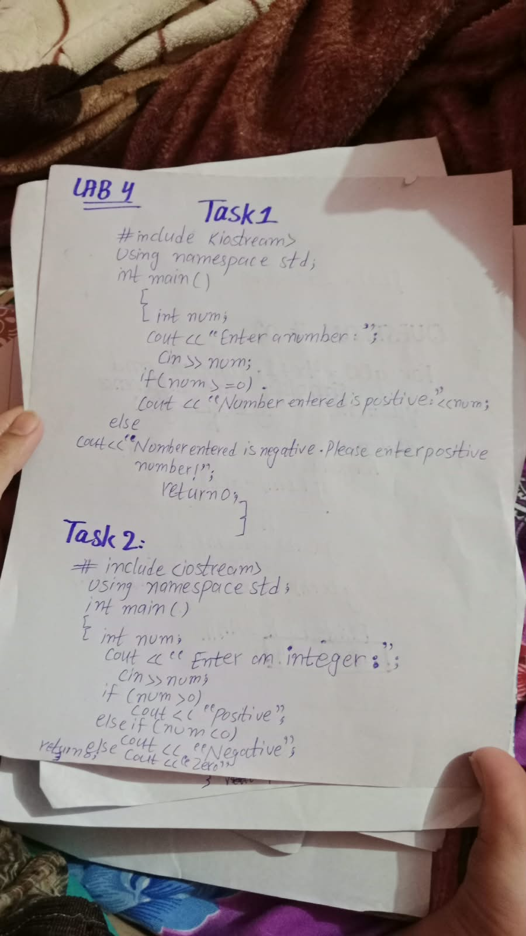
Code Written on phone/desktop
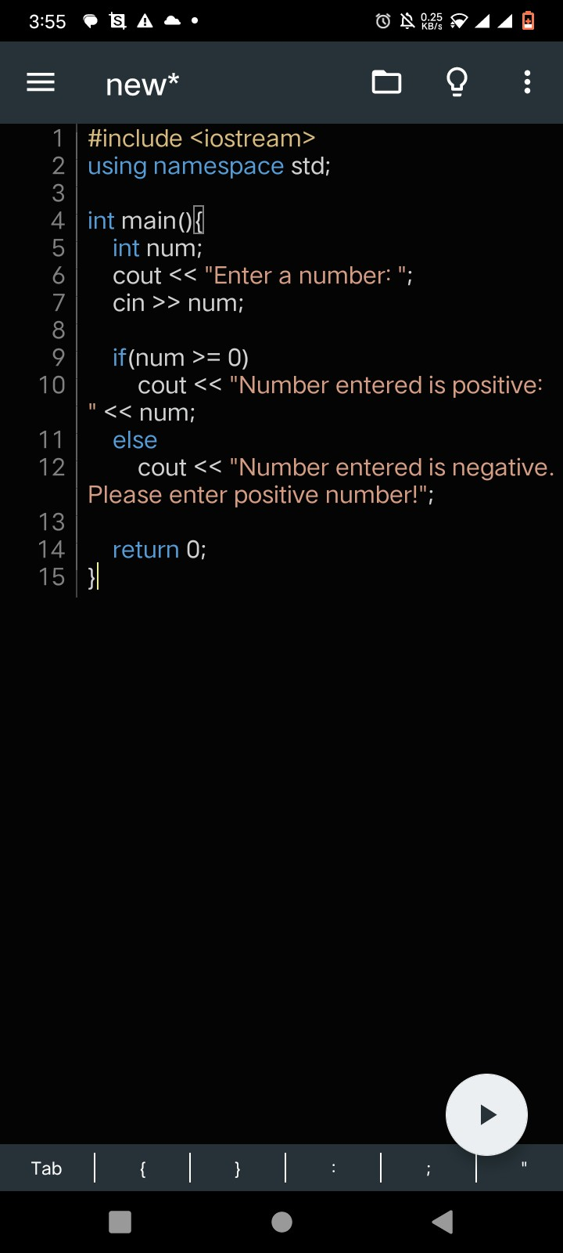
Code Output
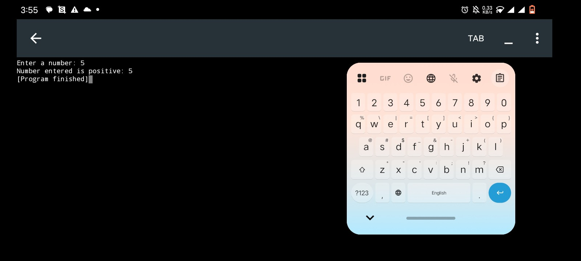
TASK 2

Code Written on phone/desktop
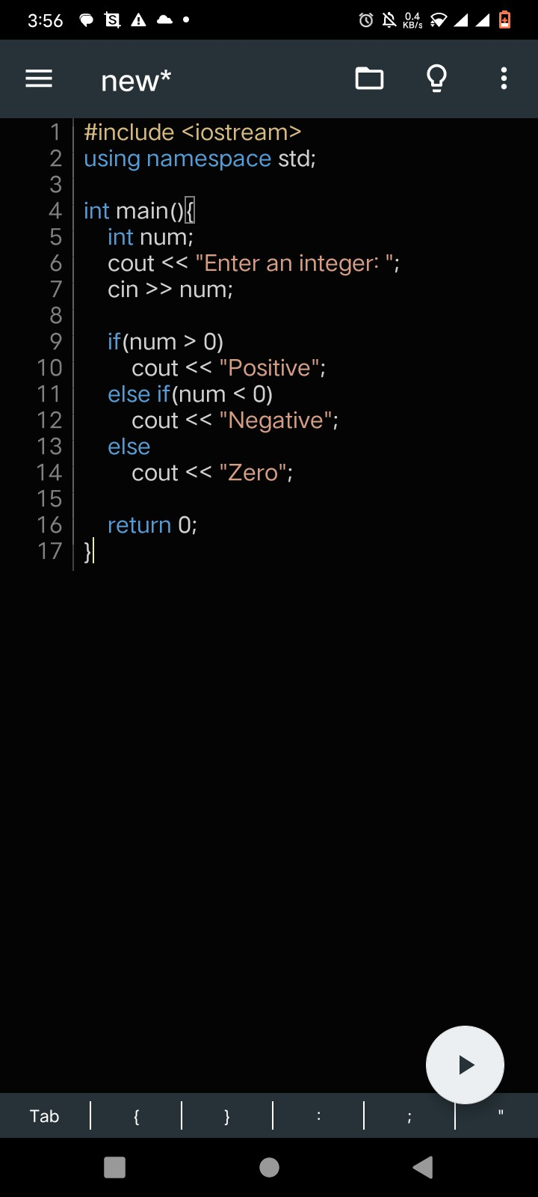
Code Output
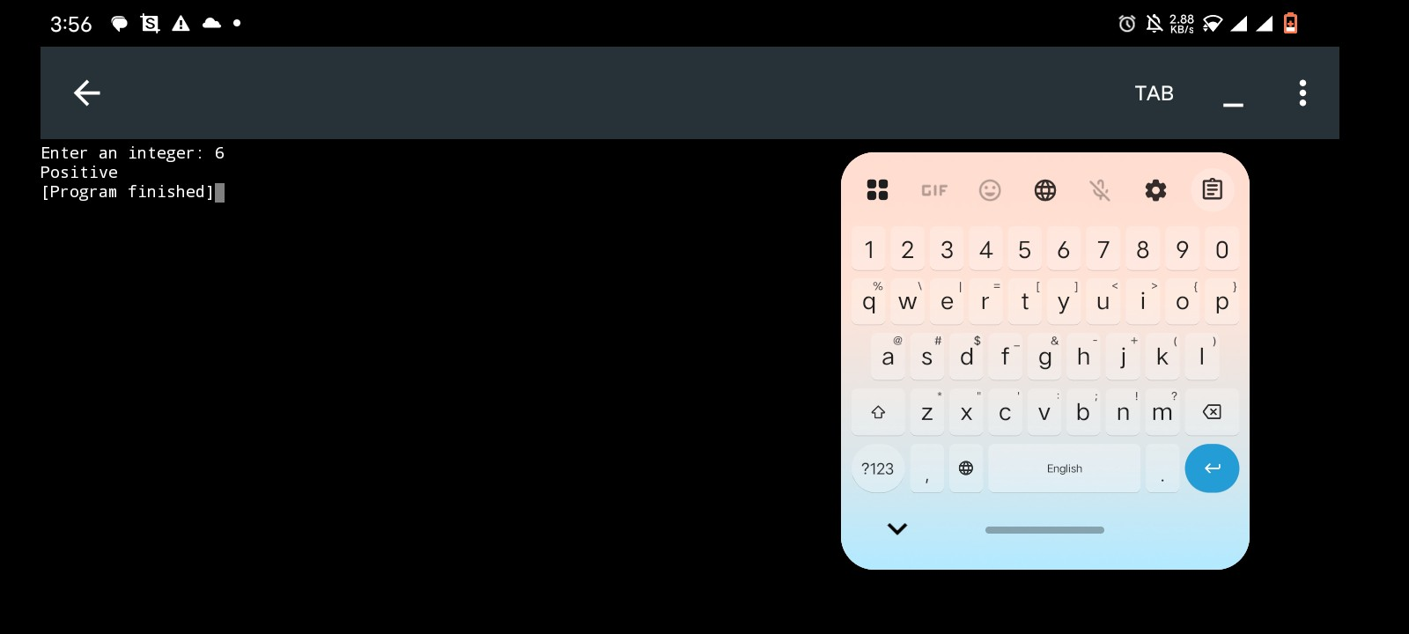
TASK 3
Handwritten Code
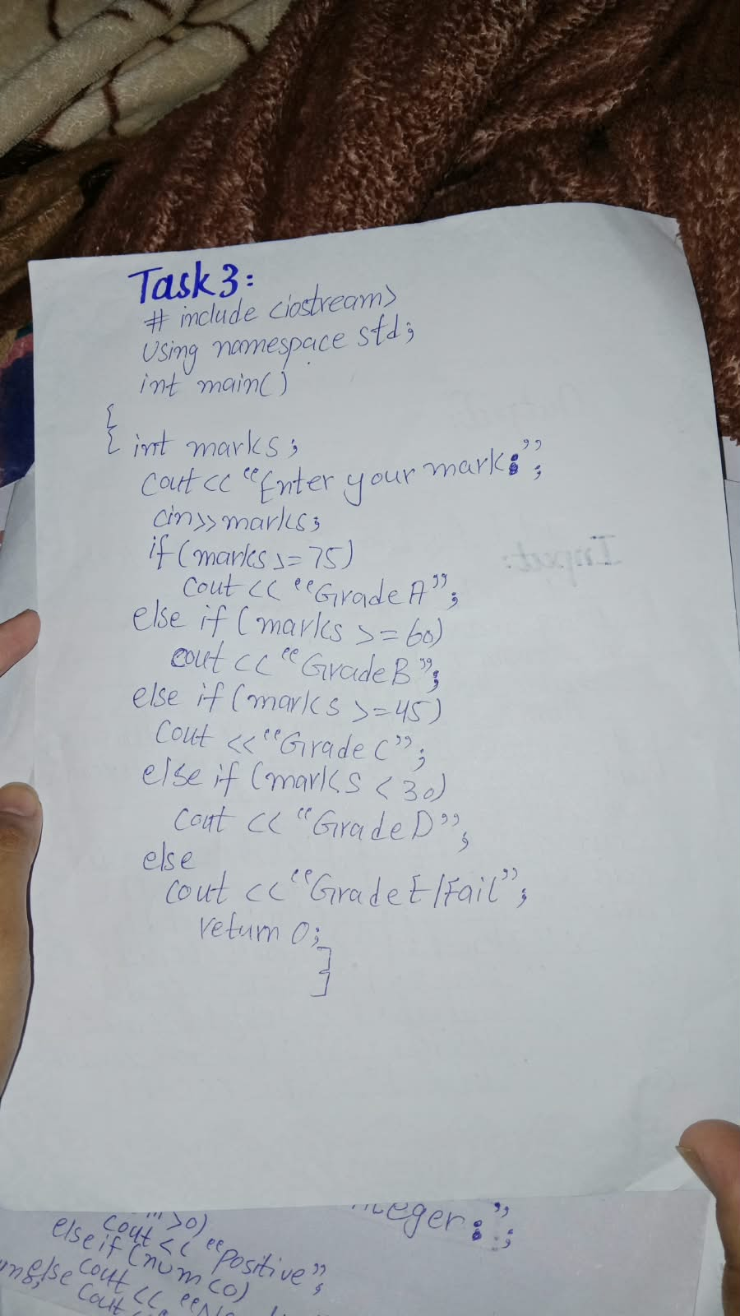
Code Written on phone/desktop
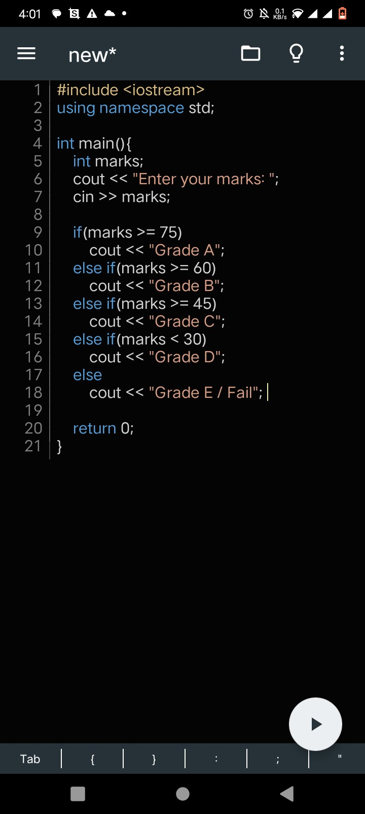
Code Output
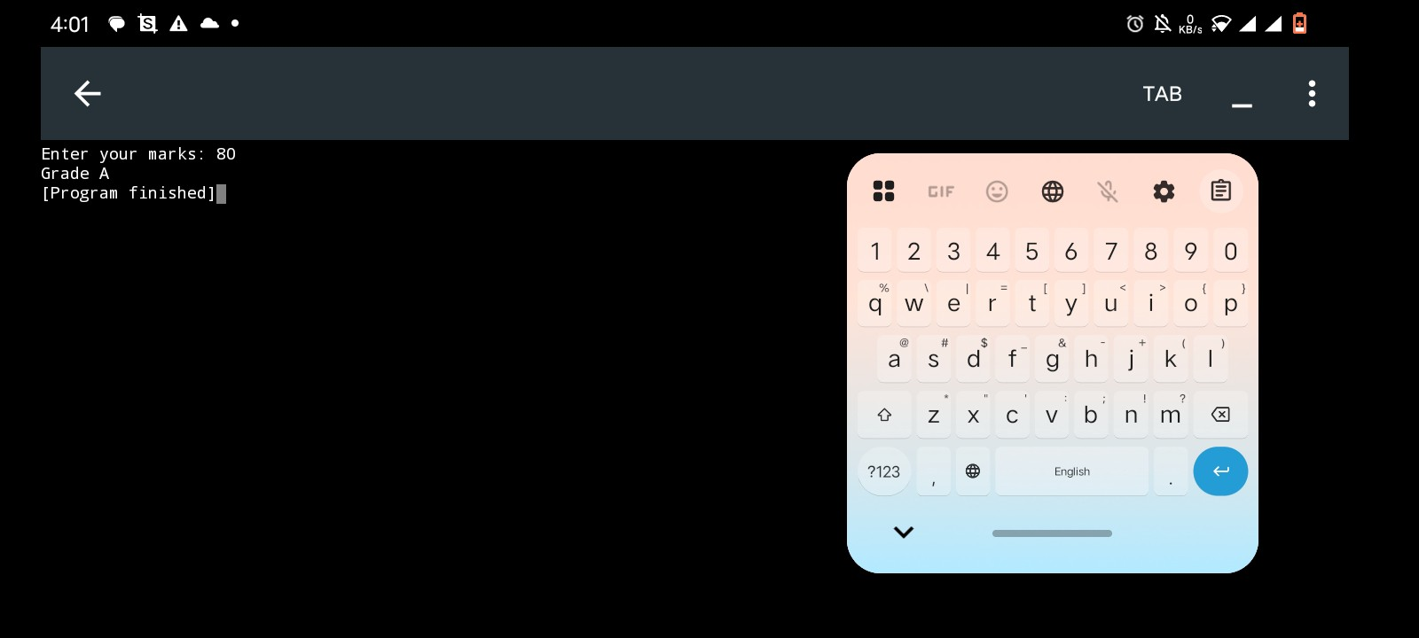
TASK 4
Handwritten Code
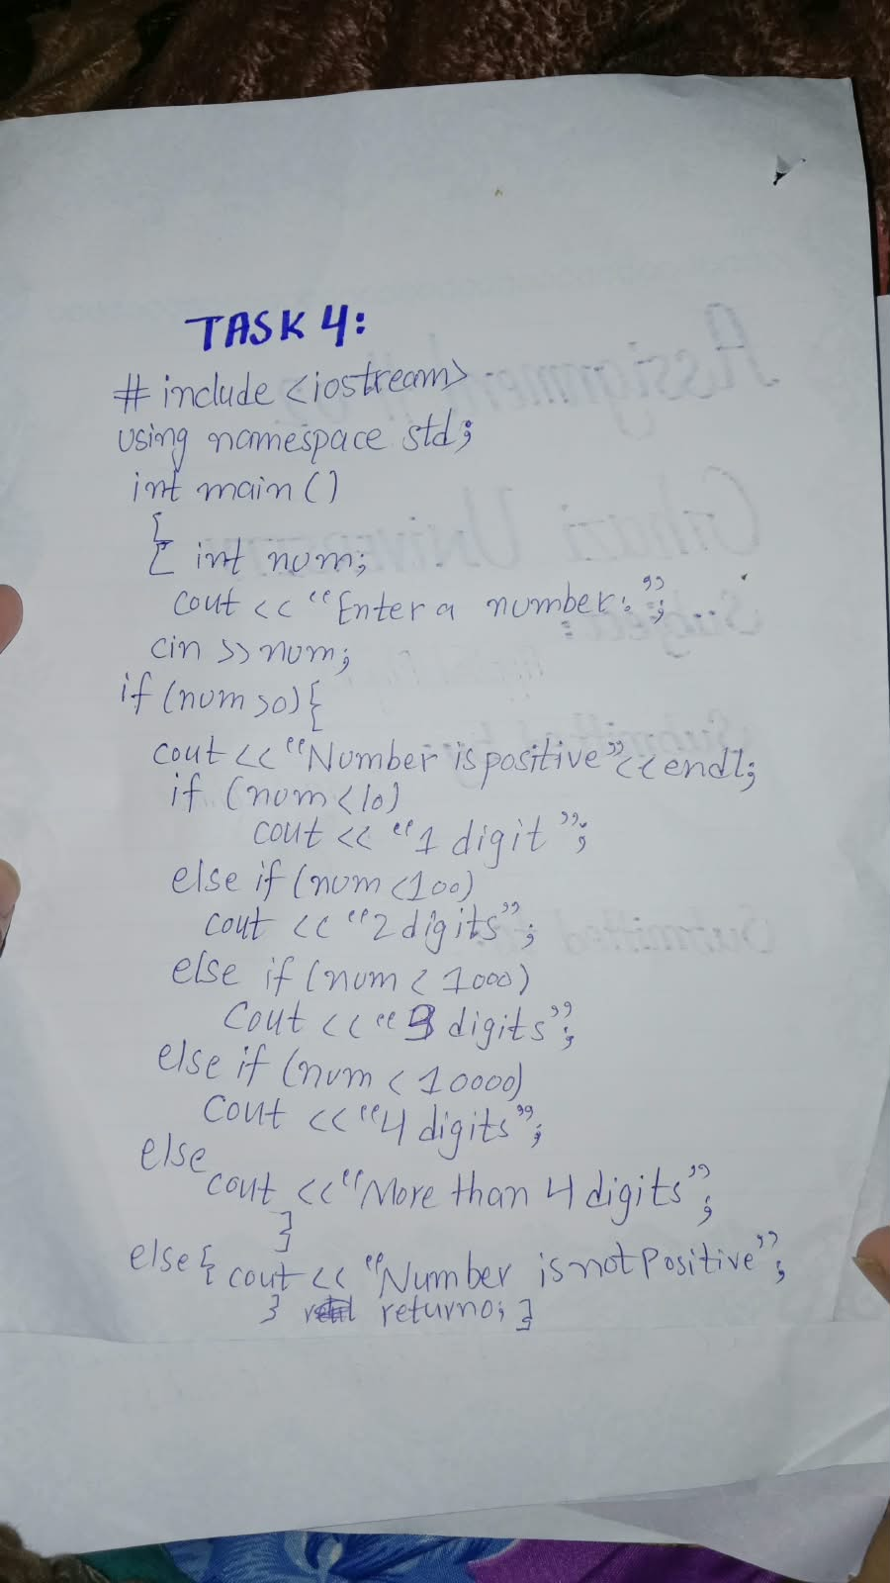
Code Written on phone/desktop
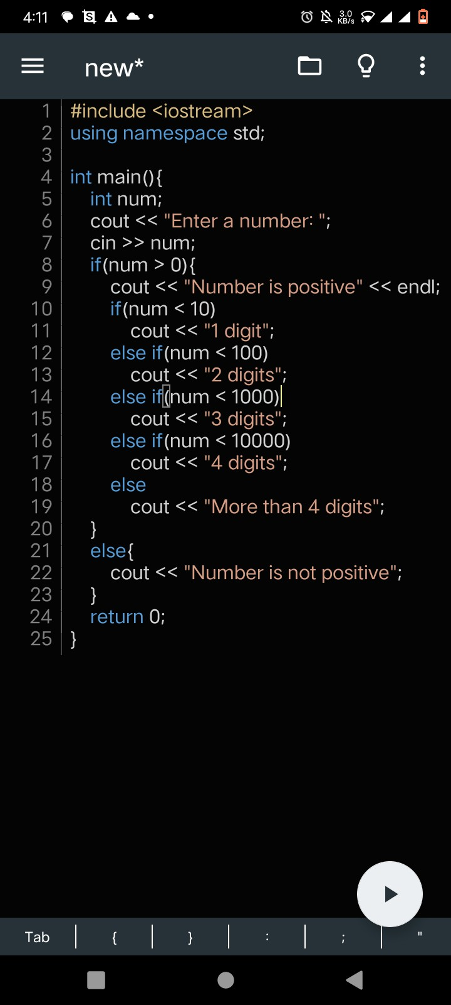
Code Output
